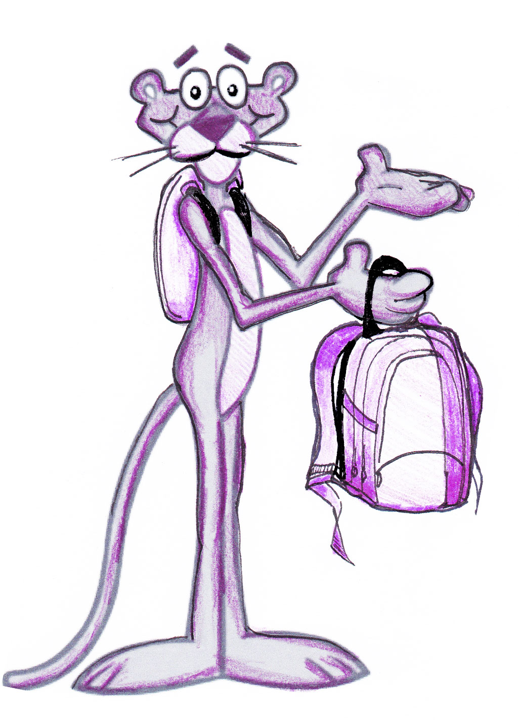
Do you need a hand figuring out how to make your backpack lighter?
We will help you! Sign up here.

NAME GRADE B-PACK WEIGHT

